EXPERIMENT 16
FOOTPRINT A WIRELESS NETWORK

1. AIM
To perform wireless network footprinting by inspecting 802.11 beacon frames, SSIDs, BSSIDs, channels, encryption types, and connected clients using Wireshark and airodump-ng.

2. THEORY
Wireless footprinting analyzes 802.11 management frames (beacon frames, probe responses) to map wireless access points, encryption algorithms (WEP, WPA2, WPA3), and connected station MAC addresses.

3. TOOLS REQUIRED
- Wireshark
- Aircrack-ng suite (airodump-ng)
- Sample .pcap capture file

4. PROCEDURE & COMMANDS
Step 1: Load Wireless Packet Capture File in Wireshark
Open capture file:
wireshark sample_capture.pcap

Step 2: Filter for 802.11 Beacon Frames
Apply display filter to isolate Access Point broadcast frames:
wlan.fc.type_subtype == 0x08

Step 3: Inspect Encryption Tagged Parameters
Expand Tagged Parameters tree in Wireshark packet details to evaluate RSN Information (WPA2) or Open status.
Step 4: Identify Connected Wireless Client Stations
Filter traffic by target Access Point BSSID MAC address:
wlan.addr == <BSSID-of-target-AP>

Step 5: Analyze Capture File with Airodump-ng
Run airodump-ng in offline read mode:
airodump-ng --read sample_capture.pcap

5. LAB OBSERVATIONS & OUTPUT SCREENSHOTS
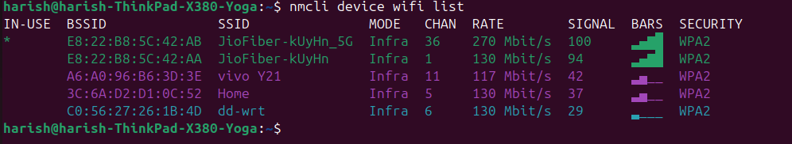

6. EXPECTED OUTPUT RESULT
Complete wireless inventory table documenting SSID names, BSSID MAC addresses, operating channels, encryption standards (WPA2-PSK), and associated client station MAC addresses.

7. VIVA VOICE QUESTIONS & ANSWERS
S.NO & VIVA QUESTION | TECHNICAL ANSWER
Q1. What is a beacon frame, and how often is it broadcast? | A beacon frame is an 802.11 management frame periodically broadcast (typically every 100ms) by an AP to announce network presence.
Q2. What's the difference between an SSID and a BSSID? | SSID is the human-readable network name. BSSID is the unique MAC address of the Access Point radio interface.
Q3. How can you tell if a network is using WPA2 vs an open network just from a beacon frame? | WPA2 beacon frames contain RSN Information tags specifying AES/CCMP. Open networks lack RSN/WPA tags.
Q4. Why would an attacker want to know which clients are connected to a target AP? | To target specific clients for deauthentication attacks, capture WPA 4-way handshakes, or attempt Evil Twin attacks.
Q5. What legal/ethical restrictions apply to live wireless footprinting outside a lab? | Sniffing wireless signals on unauthorized networks violates wiretapping and computer misuse laws.

